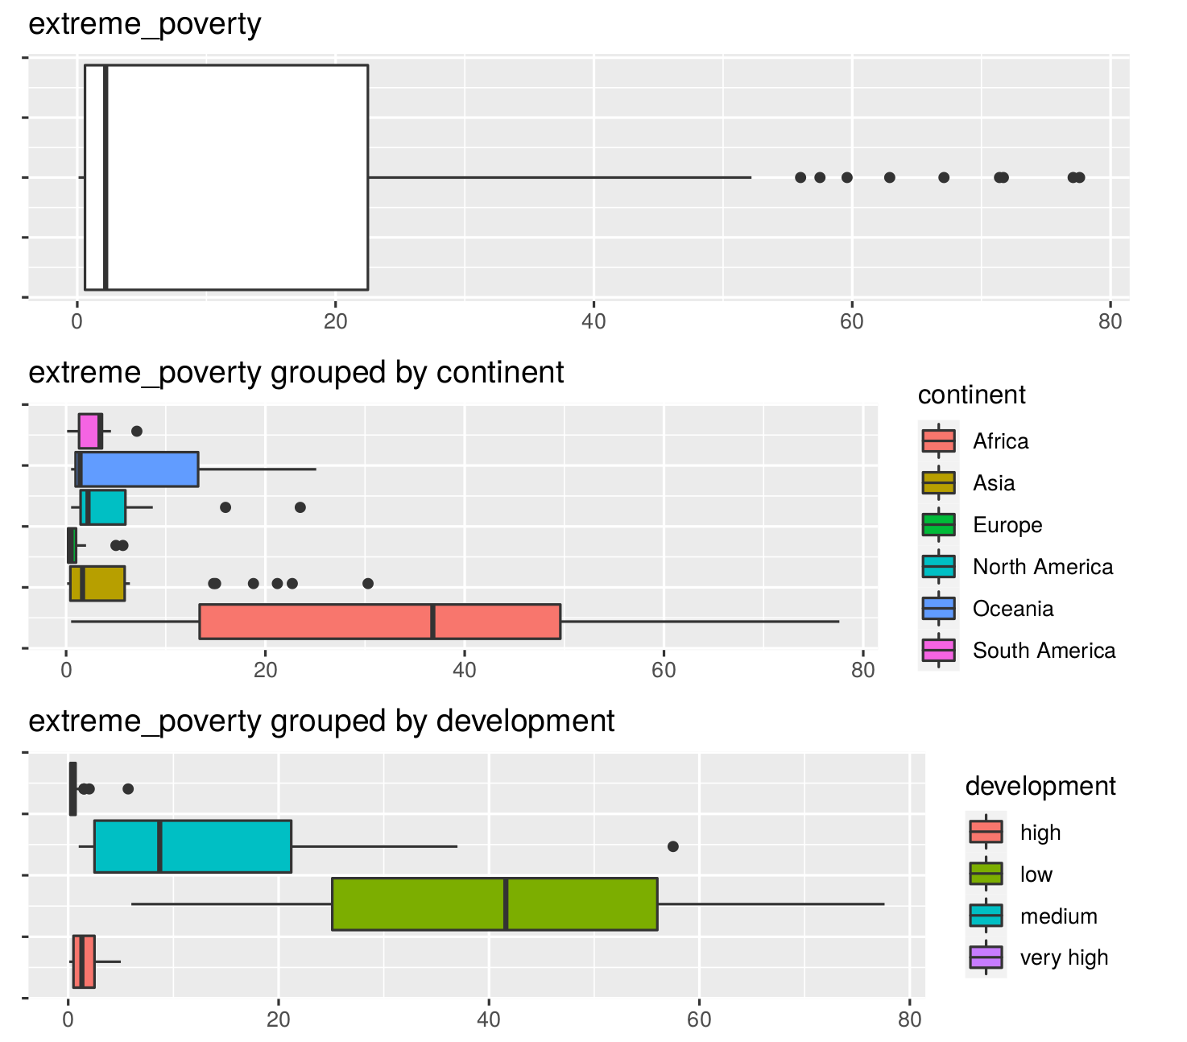 **PART 1**

There is a clear relationship between extreme poverty and very low HDI.

This pattern repeats itself, where the amount of hospital beds per thousand inhabitants, the life expectancy, gdp per capita, median age, percentage of population above 65 years of age all tend to be lower the lower the HDI.

Life expectancy itself is a component of HDI, but it is clear that all these measures are in one way or another measures of quality of life and development, therefore the higher they are, the higher HDI will also be.

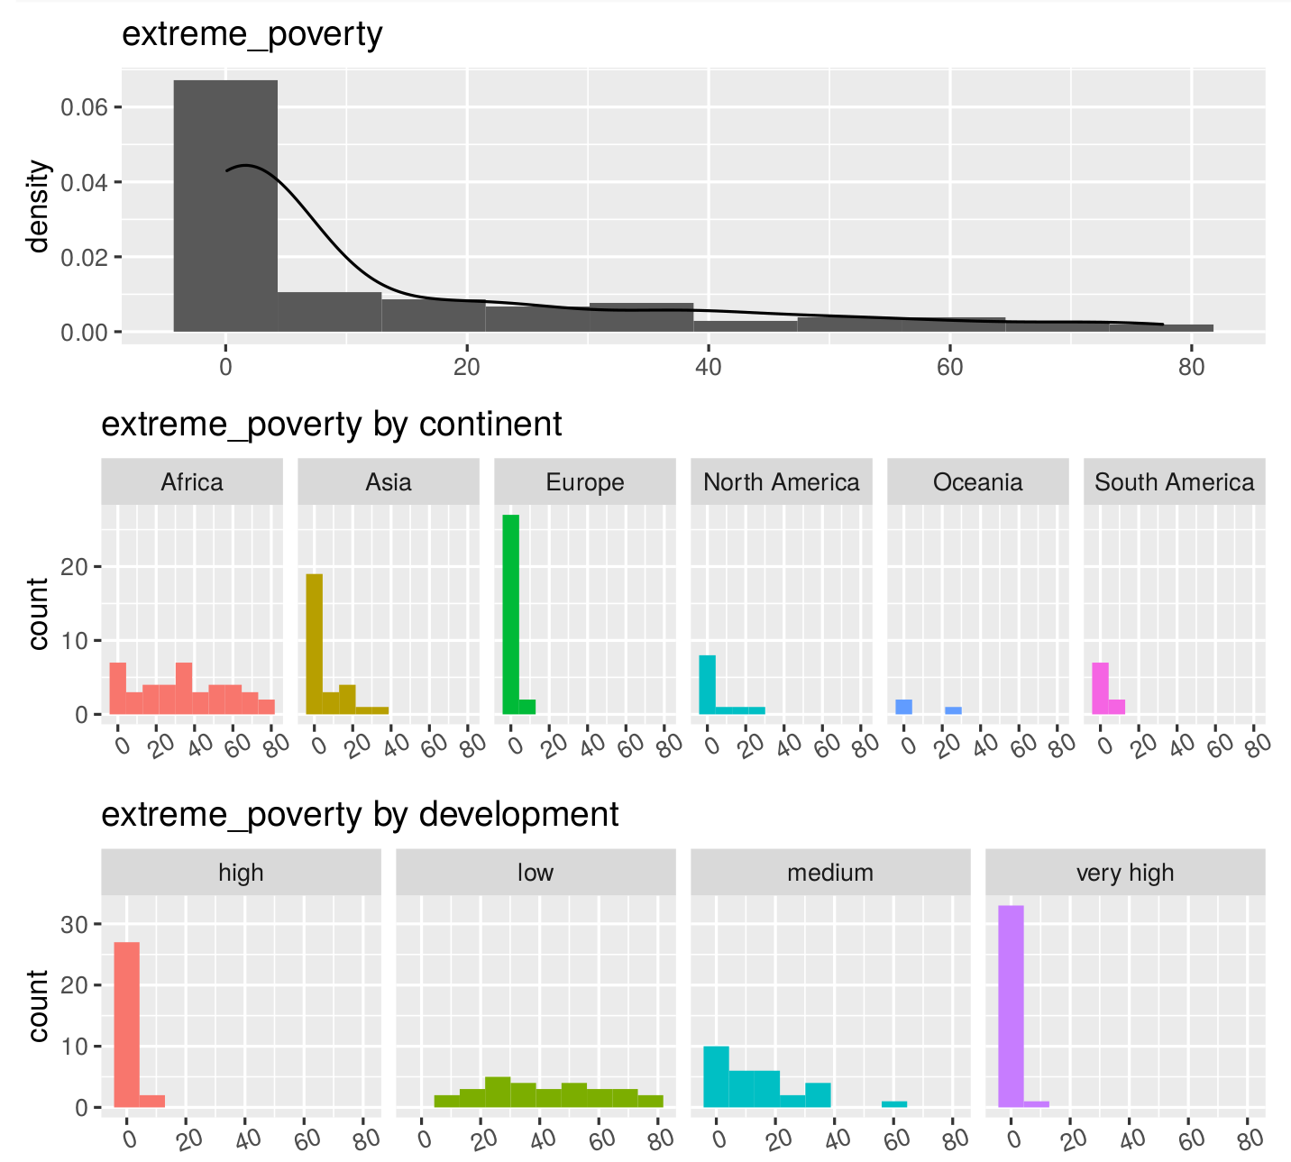The relationship between extreme poverty and HDI is the opposite, so the lower the HDI, the higher the percentage of the population living in extreme poverty conditions. **PAGES 30 AND 31**

We found that interestingly, many highly developed countries seem to be doing worse than less developed countries when it comes to handling the pandemic. However, this could be in a way countered by stating that it could all be due to less widespread testing along with how common movement of people is in more developed countries vs less developed countries.

**PAGE 45**

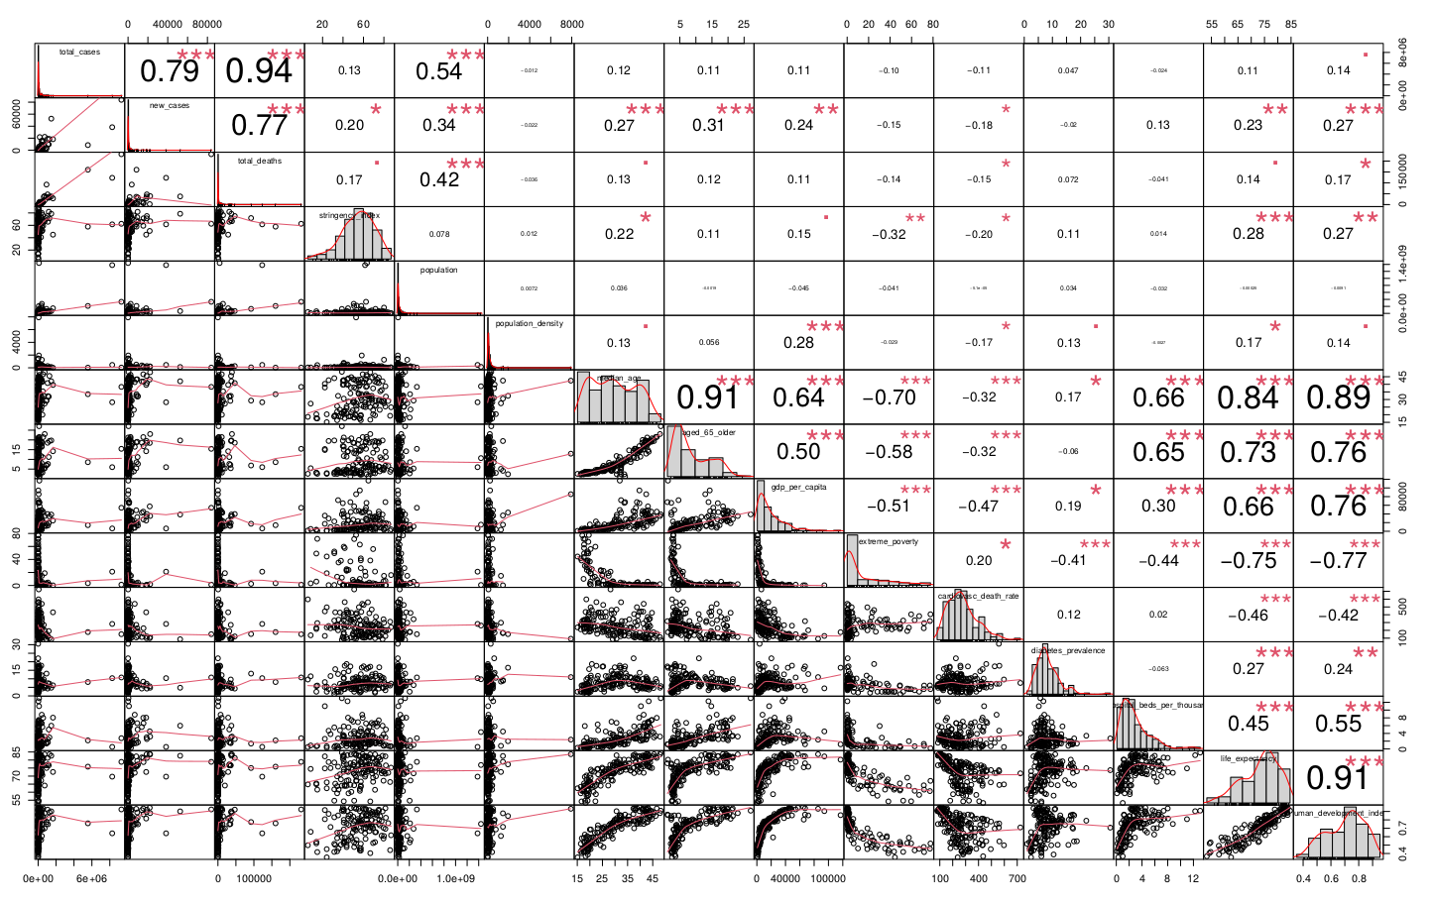Here we can see the correlations as explained previously

Usually, whenever there’s a tendency for highly developed nations to have a specifically higher metric, like gdp per capita for example, then there’s a tendency for Europe and a few other nations in other continents to be at the top, while African countries tend to be at the bottom.

This is, obviously, due to the amount of highly developed nations in Europe being somewhat matched by the amount of significantly less developed nations in Africa.

Here we clearly see Europe (green) topping most charts (with the exception of extreme poverty) and Africa at the bottom of most charts (with again the exception of extreme poverty).

In terms of the pandemic numbers, however, Africa is *usually* at the bottom of metrics. Therefore somewhat matching quite accurately with extreme poverty numbers.

**PAGE 44**

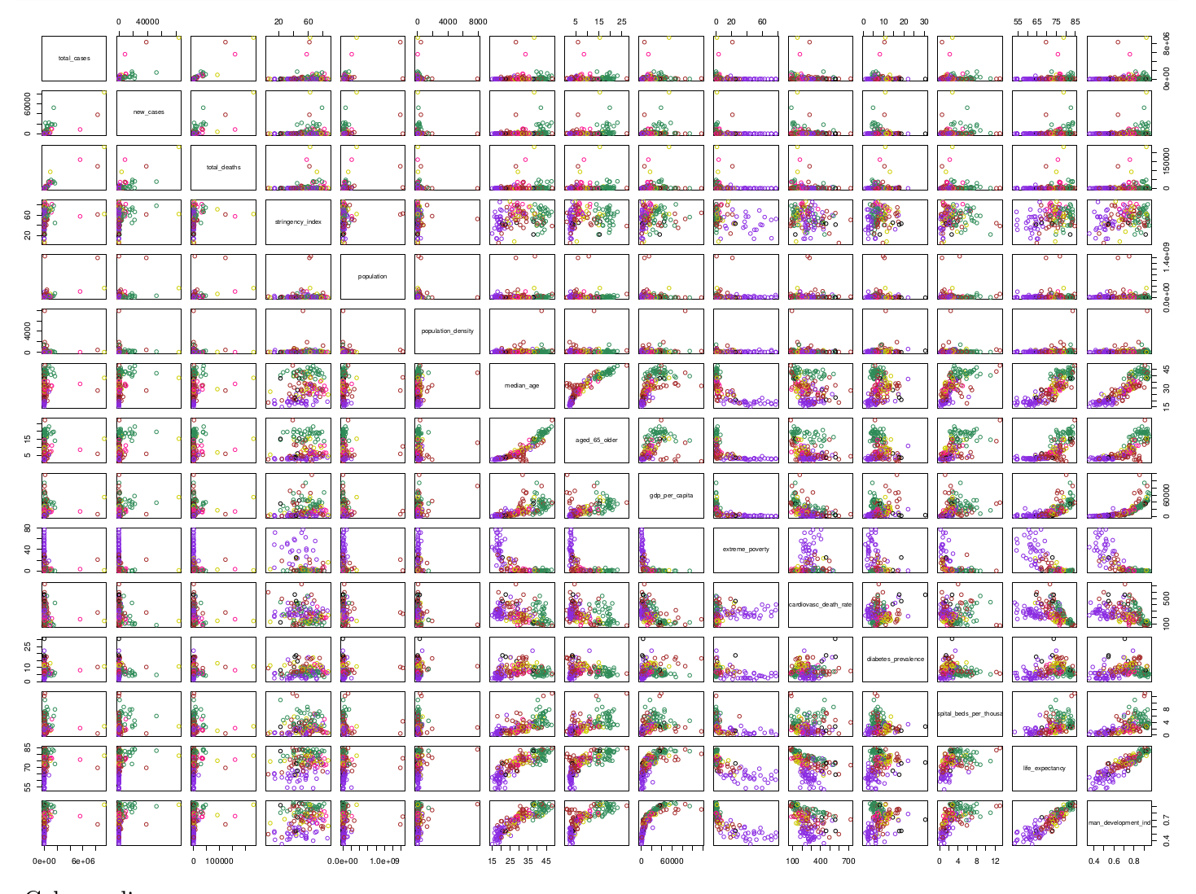

We could not directly identify any clear correlation between how poor a country is and how much the pandemic has affected it in terms of sheer case or death numbers. However, the incredibly minimal value we got for its correlation coefficient was negative, therefore maybe hinting that less developed nations could, perhaps, have a slight tendency to be less affected by the pandemic in terms of case/death numbers.

We did however find that the restrictions in extremely poor nations tended to be, to an extent, less strict.

As for imputation of missing values, there are several methods in the mice function, the one we chose is ‘cart’, which uses classification and regression trees.

We have two categorical variables, when grouped by HDI: there’s a tendency for the mean vector to be affected by its HDI categorization, clearly showing the previously explained relationship between the variables.

However, when grouped by continent, there is no sign of such trend with the minor exception of maybe Europe and African values varying to certain degrees of difference, due to the significant difference in amounts of developed and underdeveloped nations.

Comparing the linear relationships in different groups by calculating correlation matrix, we have some interesting outcomes:

Apart from some obvious linear relationship between median age and proportion of population over 65 years old, life expectancy and human development index. (PAGE 57)

For almost all subsets, total cases, new cases and total death are strongly linearly related. An obvious thing to point out, but makes a lot of sense.

When grouping we see some interesting patterns:

For those countries with very high development index, diabetes prevalence has a negative linear relationship with proportion of population over 65 years old. (PAGE 61)

For Asia, there exists a linear relationship between total cases and population, which doesn’t show in any other subset, this relationship could be significantly skewed by the fact that india, with the second highest world population, has been one of the most affected countries during the pandemic. Being also, coincidentally the 2nd most affected country by the pandemic. (PAGE 63)

And for Africa, median age is negatively correlated with gpd per capital, life expectancy and human development index. (PAGE 64)

In Europe, cardiovascular death rate has negative linear relationship with life expectancy and human development index. (PAGE 66)